Muller Plots
These plots compare 1 wild-type mutant and one of higher starting fitness, using either a linear or exponential (decreasing) function for fitness for the non-wild-type clone.

No. starting wild-type cells | No. starting higher fitness cells | Muller Plot | Linear or Exponential?
500 | 500 | 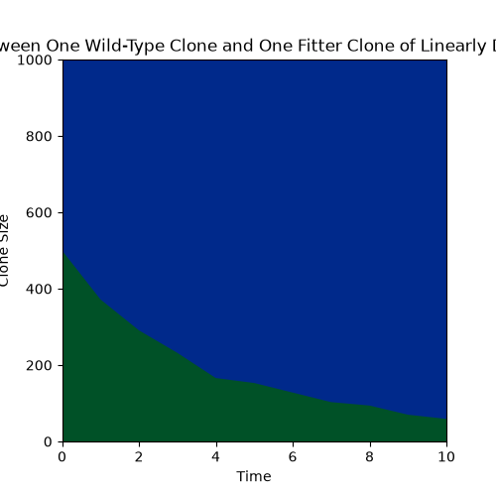 | Linear
500 | 500 | 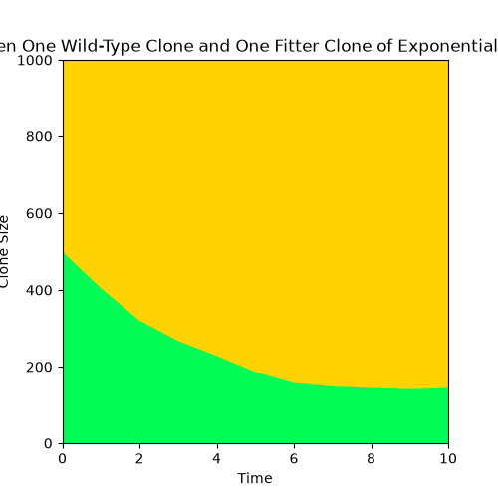 | Exponential
250 | 750 | 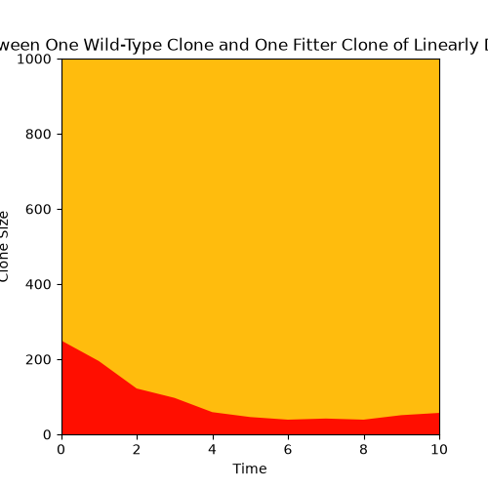 | Linear
250 | 750 | 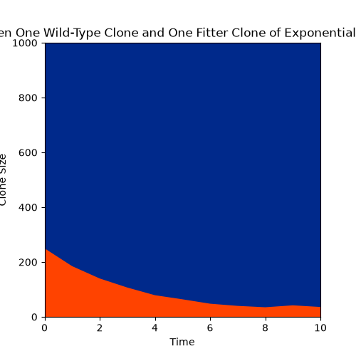 | Exponential
750 | 250 | 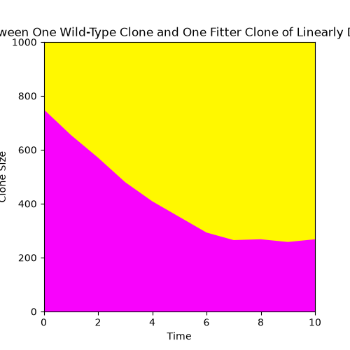 | Linear
750 | 250 | 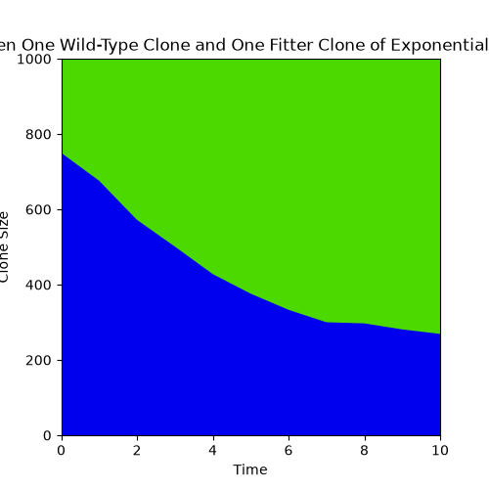 | Exponential

